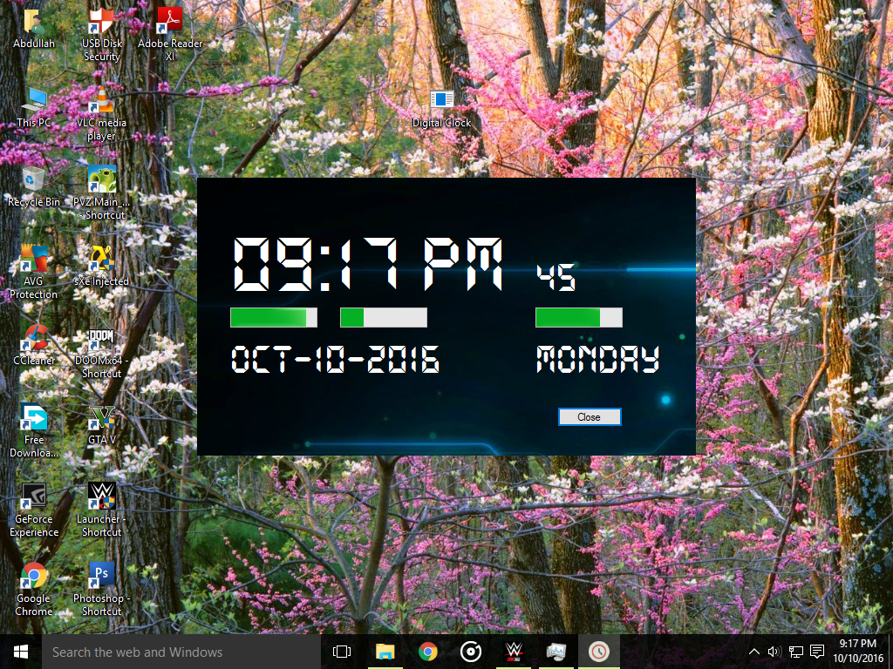

Coding (Visual Studio 2015):
using System;
using System.Collections.Generic;
using System.ComponentModel;
using System.Data;
using System.Drawing;
using System.Linq;
using System.Text;
using System.Threading.Tasks;
using System.Windows.Forms;

namespace Digital_Clock
{
public partial class Form1 : Form
{
public Form1()
{
InitializeComponent();
}

private void timer1_Tick(object sender, EventArgs e)
{
label1.Text = DateTime.Now.ToString("hh:mm tt");
label2.Text = DateTime.Now.ToString("ss");
label3.Text = DateTime.Now.ToString("MMM-dd-yyyy");
label4.Text = DateTime.Now.ToString("ddddd");
progressBar1.Value = DateTime.Now.Hour;
progressBar2.Value = DateTime.Now.Minute;
progressBar3.Value = DateTime.Now.Second;
}

private void progressBar1_Click(object sender, EventArgs e)
{

}

private void button1_Click(object sender, EventArgs e)
{
MessageBox.Show("Made By Abdullah Safwan Hashmi (A.S.H)" + Environment.NewLine + "jonesanderson768@gmail.com");
this.Close();
}
}
}

